IoT Analytics
Multivariate Signals and Unstructured data for HD sensors for Home/Office Automation

An Analytics Layer Supporting Network of AI agents at the Edge, Working in Hubs, Achieving Human Level Cognition, Security, and Protection of People, Assets, Animals, and Environment, collaborating at the community and regional level
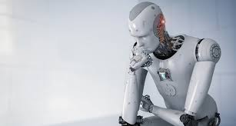
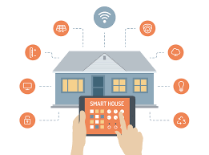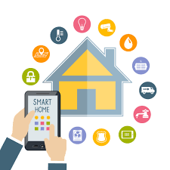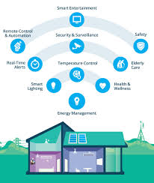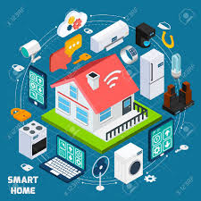
Pictures: Google.com

When the Edge computing, Sensors HUB, Secured Block Registers, and AI converge, watch out you do not become a PHEB( Pointy, Hubby, Edgy, and Blocky)

A well-engineered data capture, data analytics, and consumer UI is fundamental to your eco-system not to turn into a PHEB, and become an intelligent AI.

Situation Analysis - IoT
25 Billion sensors by 2020
Cisco and McKinsey predicting $33T in the next 10 years
Knowledge management (ML, AI, and Cognitive and Collaborative Agents) is the maximum impact area affecting all with $5.2 T
IOT market is growing 40+ %; any disruptive leadership work will sustain or grow this through out the next two decades – recall the speed of adoption of smart phone in the last decade

Top concerns:
Data privacy – 40%
Security – 40%
High cost of implementation – 38%
Not enough knowledge about available solutions – 38%
Inadequate infrastructure – 33%
Lack of standards – 29%
Interoperability concerns and legacy systems – 28%
Uncertainty in outcomes influencing the benefits – 27%
Current workflow not well defined – 26%
Technology is not mature: 24%

The Chaos
Sensors, Data, Events, are
- Disparate
  - In the case of, say home, the sensors are
    - Heat
    - Gas
    - Water
    - Electricity
    - Bulbs
    - Garage
    - Pipes
    - Animals
    - Videos
    - sound sensitive patterns
- Multidimensional time series data
- Wifi data capture
  - Multivariate Time Series
  - Too many sensors
  - Possibly too many false positives and potentially false negatives also
  - High dimensional data
  - Big data situation

- How to get human level cognition, security, and protection of people, animal, and environment?

Solution: An HD HUB, with HD cognition, for HD monitoring by network of AI agents

The Architecture of connectedness
- The HUB where edge instruments are connected for broadband and cloud connectivity
- The cloud
- Edge AI to HUB AI
- A constantly learning network of AI agents
- HD cognition

What defines MVAM (Minimum viable, acceptable market) Leader?

Security
- Each of the sensor and its wifi has enormous potential for security breach
- Through one sensor a network of sensors will be breached
- Through one home/office, a network of communities will be breached
- A whole nation stand still is waiting to happen
Solution: Block chain, as a trust maintainer in the IOT security
Human level cognition is MVAM as our product
- A FP or FN can lead to 10’s of thousands of dollars of loss in a home or an office, and talk about peace of mind
- Massive amounts of data from continuous feeds of 100 plus sensors in a home will lead to frustrating levels of FPs and FNs
- The hub and edge computing methods are looking for ways to resolutions and cognition at the edge and provide information to a central source of the networked AI agents to back to the Hub

There are many examples why you need analytics and especially Multivariate time series analysis of multiple signals.
Talk to us

Proprietary Edge Computing Implementation Architecture and Solutions

A smart edge analytics HUB that works with 100+ sensors, from each of the HUB and millions of HUBs at the AI super center
A specific collection of machine learning algorithms; not all will work
Using all the data points continuously, and yet keeping minimal features and rules with Bayesian updating procedures
A specific engineering of reporting of data, engineering of data, and engineering of cognitive computing
An optimized way of trigger and decision management for HD cognition for HD HUB by a consistent collective intelligence of network of AI agents

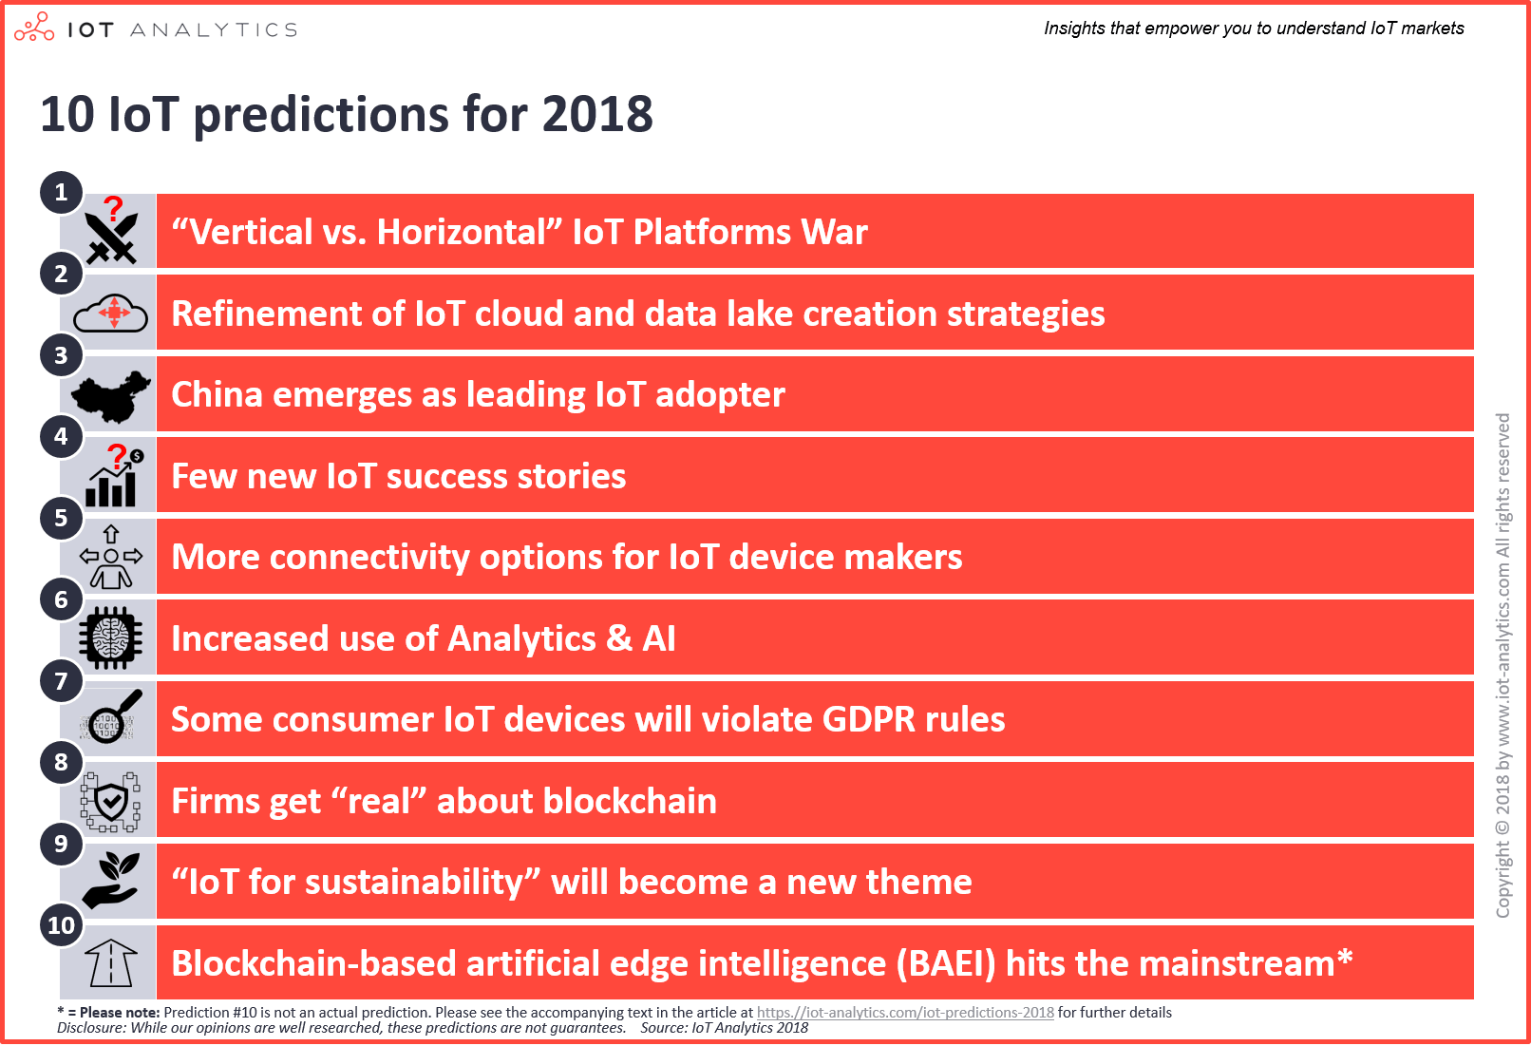
References:
https://arxiv.org/pdf/1311.4112.pdf
https://www.forbes.com/sites/bernardmarr/2017/02/07/iot-and-big-data-at-caterpillar-how-predictive-maintenance-saves-millions-of-dollars/#5f85aa687240
http://lipas.uwasa.fi/~bepa/Multivariate.pdf
https://www.sciencedirect.com/science/article/pii/S1532046408000634
http://www.ifs.tuwien.ac.at/~silvia/idamap99/idamap99-09.pdf
http://personal.vu.nl/s.j.koopman/old/publications/multi_stsm.pdf
https://faculty.washington.edu/ezivot/econ584/notes/varModels.pdf
https://www.bauer.uh.edu/rsusmel/phd/ec2-6.pdf

Source: http://www.ioti.com/security/top-10-reasons-people-aren-t-embracing-iot

